Name :

Ghazal Fatima
Roll No:
31
Program :
Computer Science
Section :
A
Submitted To:
Sir Asad Majeed
Date:
15-10-2026

LAB # 3

Task 1:
Assume that the following variables are defined:
int age;
double pay;
char section;
Write a single cin statement that will read input into each of these variables.
Handwritten code
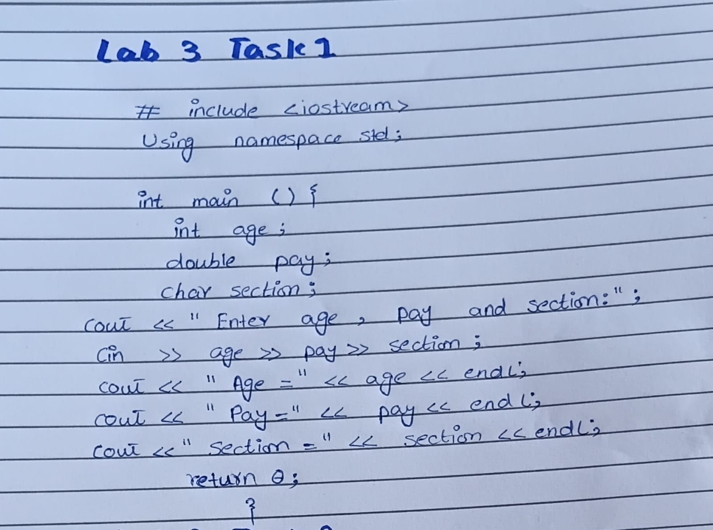
Code written on Desktop
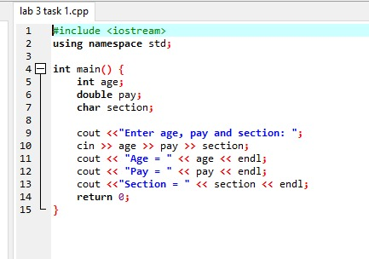
Output
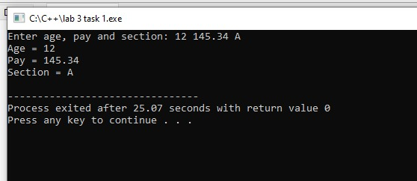

Task 2:
Complete the following table
according C++ language rules.
Expression
by writing the value of each expression in the Value column
Value
28/4-2
6+12*2-8
4+8*2
6 +17 % 3:- 2
2 + 22 * (9-7)
(8 + 7) *2
(16 + 7) % 2-1
12 / (10 - 6)
(19 - 3) * (2+ 2)/4

Handwritten Page
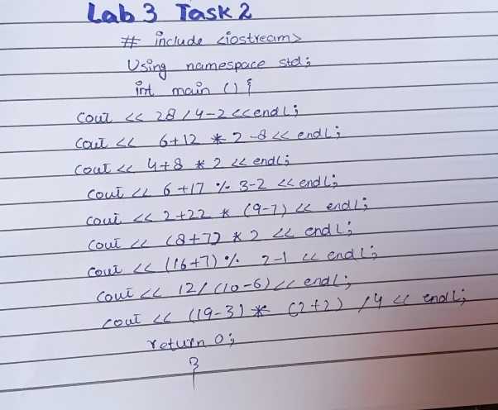
Code Written on Desktop
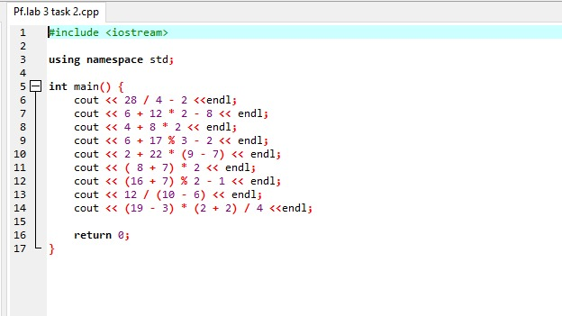
Output
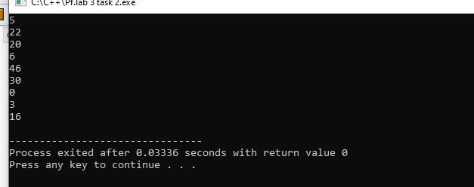

Task 3:
Assume a program has the fol
lowing variable definitions:
int units;
float mass;
double weight;
weight = mass * units;
Which automatic data type conversion will take place?
A. mass is demoted to an int, units remains an int, and the result of mass * units is an int.
B. units is promoted to a float, mass remains a float, and the result of mass * units is a float.
C. units is promoted to a float, mass remains a float, and the result of mass * units is a
double.
Handwritten Code

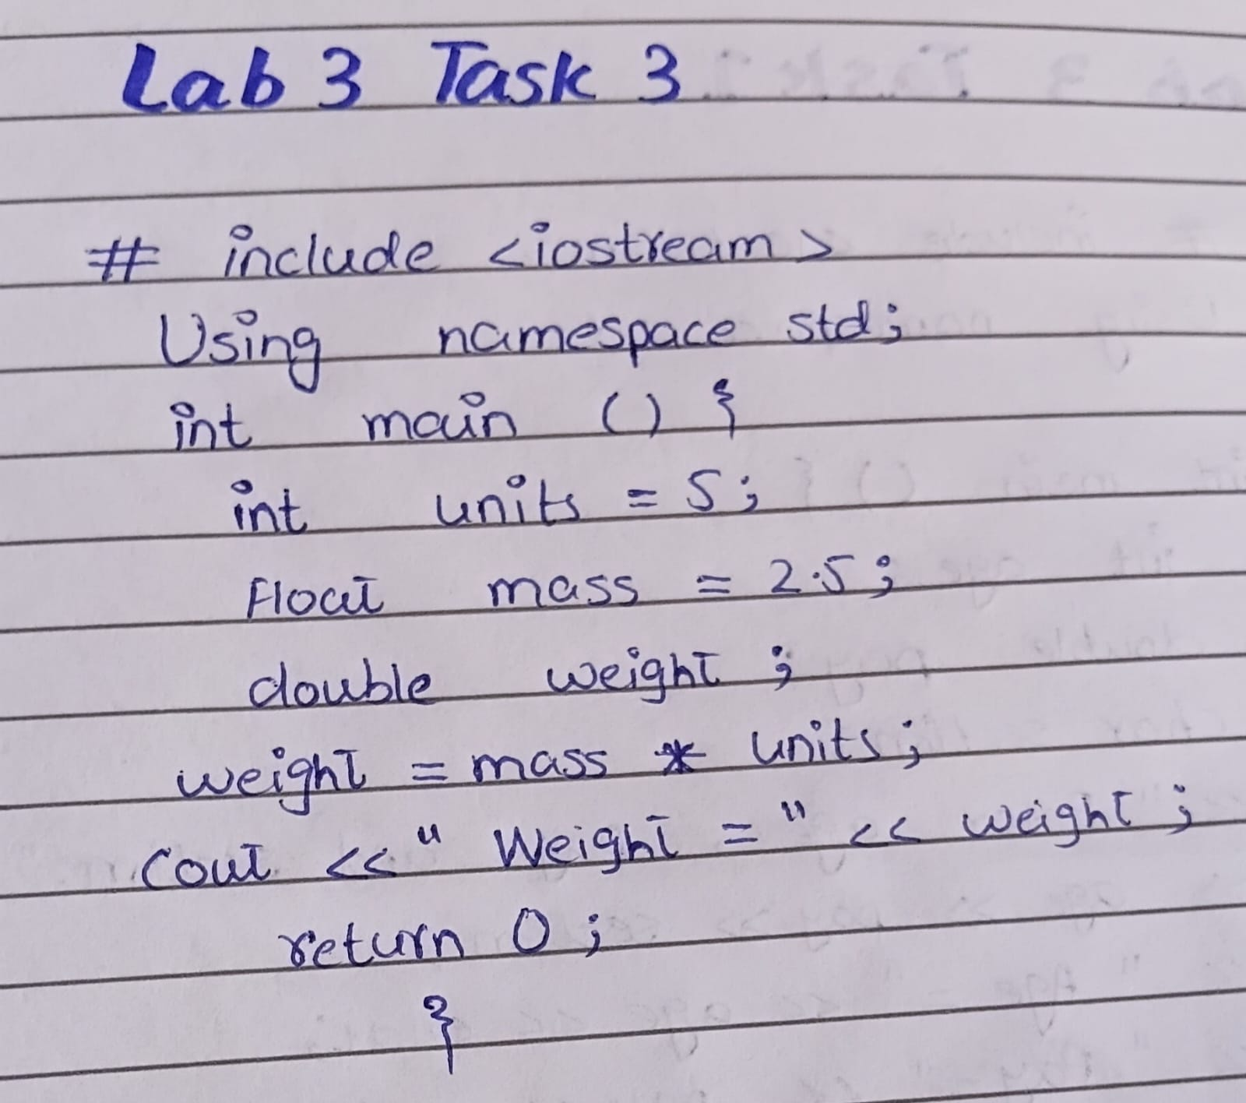
Code Written on Desktop
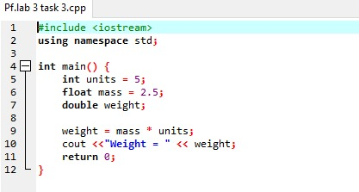
Out Put
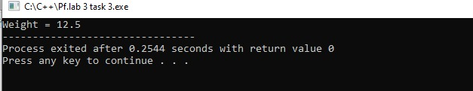

Task 4:
Assume a program has the following variable definitions:
int a, b = 2; floatc=4.2;
and the following statement: a = b * c;
What value will be stored in a?
A. 8.4 B.8 c.0 D. None of the above
Handwritten Code
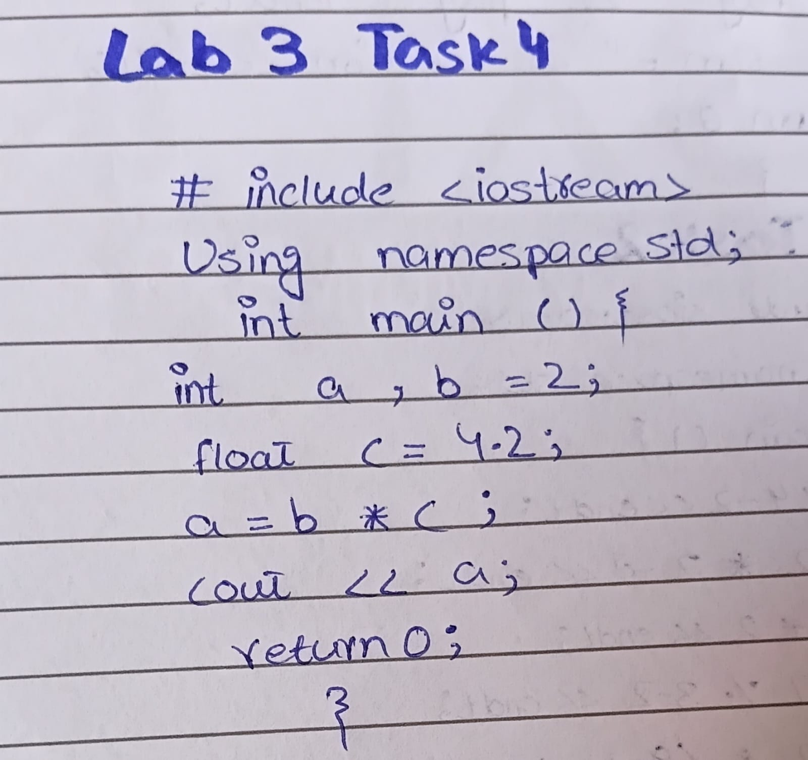
Code Written on Desktop
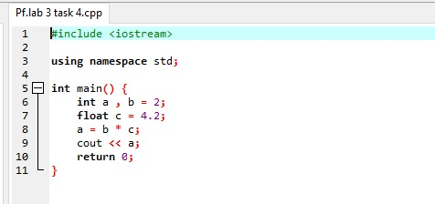
Out Put
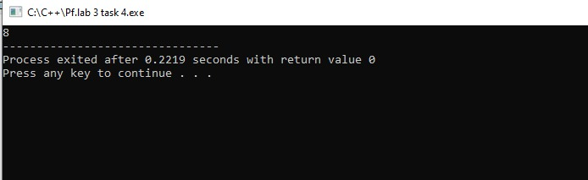

Task 5:
Assume that qty and salesReps are both integers. Use a type cast expression to rewrite the
following statement so it will no longer perform integer division.
unitsEach = qty / salesReps;

HandWritten Code
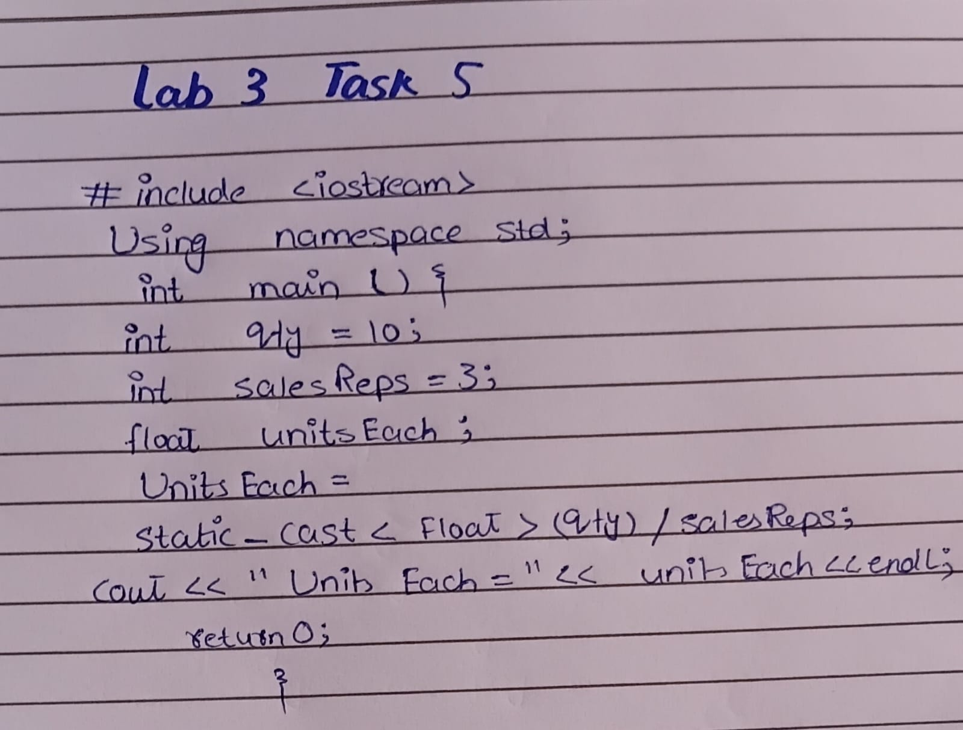
Code Written on Desktop
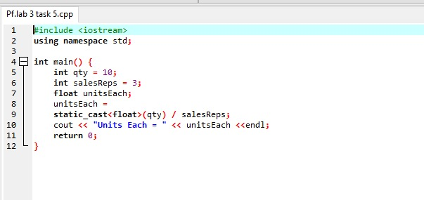
Out put
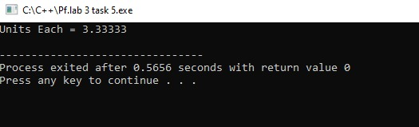

Task 6:
Math Tutor: (hint rand())
Write a program that can be used as a math tutor for a young student. The program should
display two random numbers to be added, such as
247
+129
The program should then pause while the student works on the problem. When the student
is ready to check the answer, he or she can press a key and the program will display the
correct solution:
247
+129
Hand Written Code
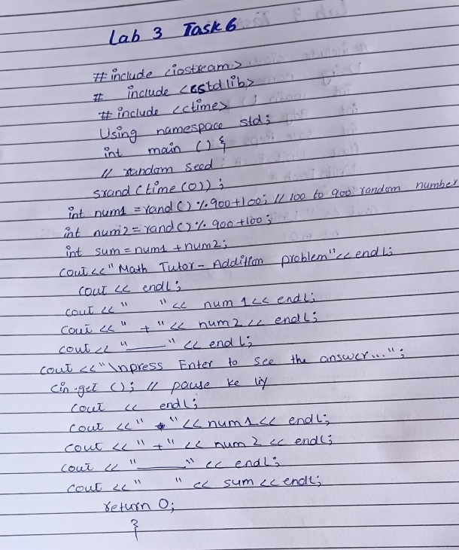
Code Written on Desktop
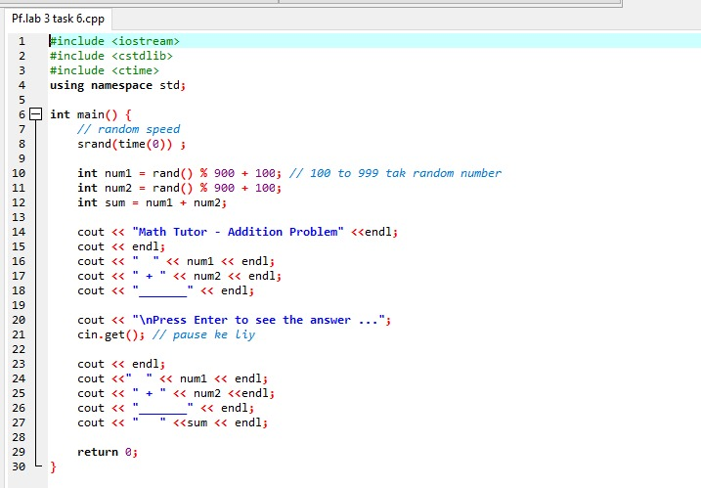
Out Put
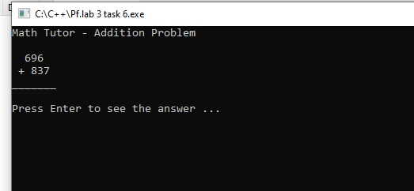

Home Tasks:

Task 1:
Each of the following programs has some errors. Locate as many as you can.
Program-1
using namespace std;
void main()
{
double number1, number2, sum;
cout << "Enter a number: ";
cin << number1;
cout << "Enter another number: ";
cin << number2;
number1 + number2 = sum;
cout "The sum of the two numbers is " << sum
}
Hand Written Code
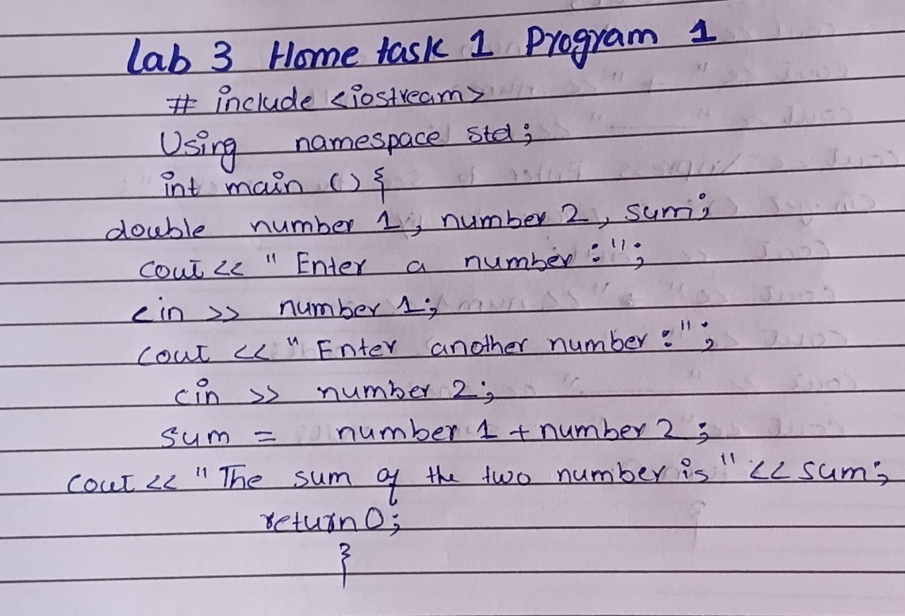
Code Written on Desktop
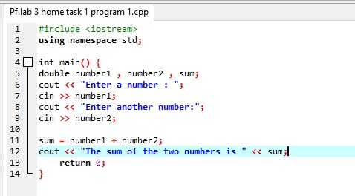
Out Put
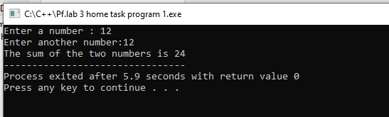
Program-2
#include <iostream>
using namespace std;
void main()
{
int number1, number2;
float quotient;
cout << "Enter two numbers and | will divide\n";
cout << "the first by the second for you.\n";
cin >> number1, number2;
quotient = float<static_cast>(number1) / number2;
cout << quotient

Hand Written Code
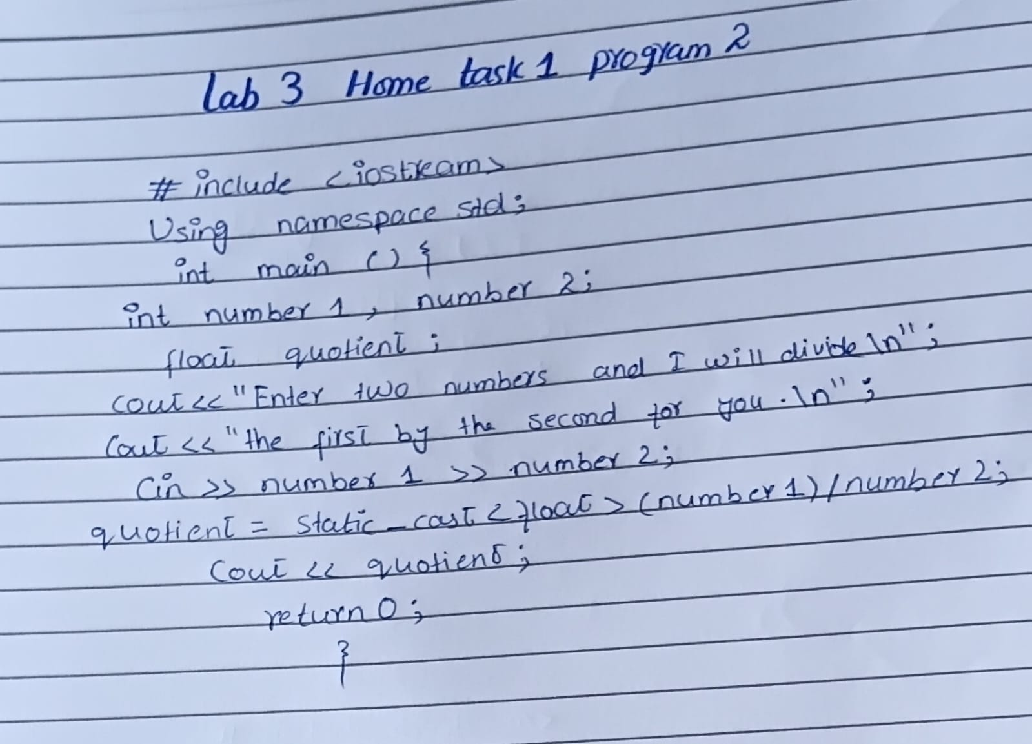

Code Written on Desktop
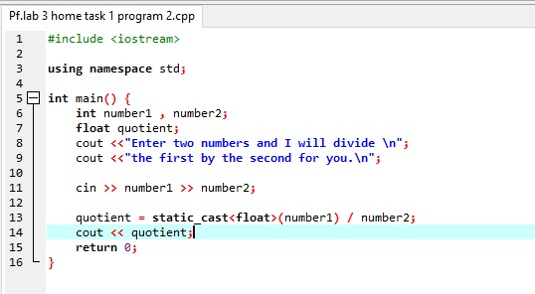

Out Put
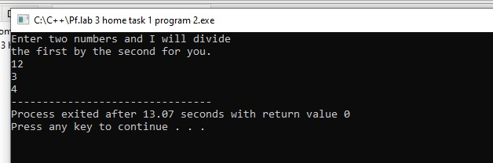

Task 2:
Average of Values to get the average of a series of values, you add the values up and then
divide the sum by the number of values. Write a program that stores the following values in
five different variables: 28, 32, 37, 24, and 33. The program should first calculate the sum of
these five variables and store the result in a separate variable named sum. Then, the
program should divide the sum variable by 5 to get the average. Display the average on the
screen.

Hand Written Code
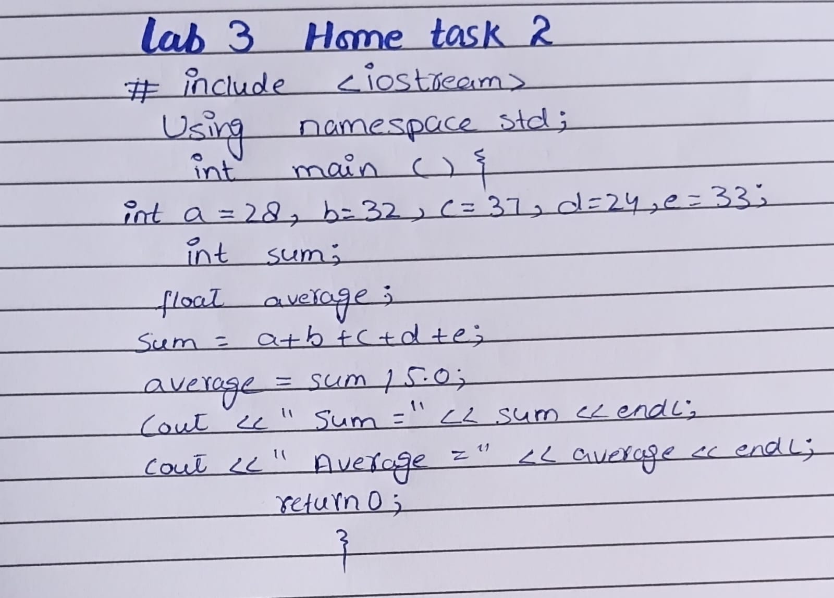
Code Written on Desktop
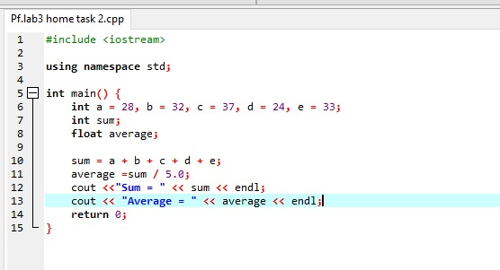
OUT Put
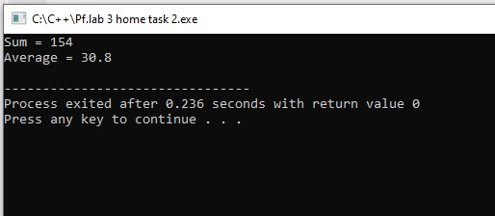
LAB #04: If statement

Task1:
Write a program to print positive number entered by the user.
f the user enters negative number print number entered is positive otherwise print number is
negative.
Hand Written Code
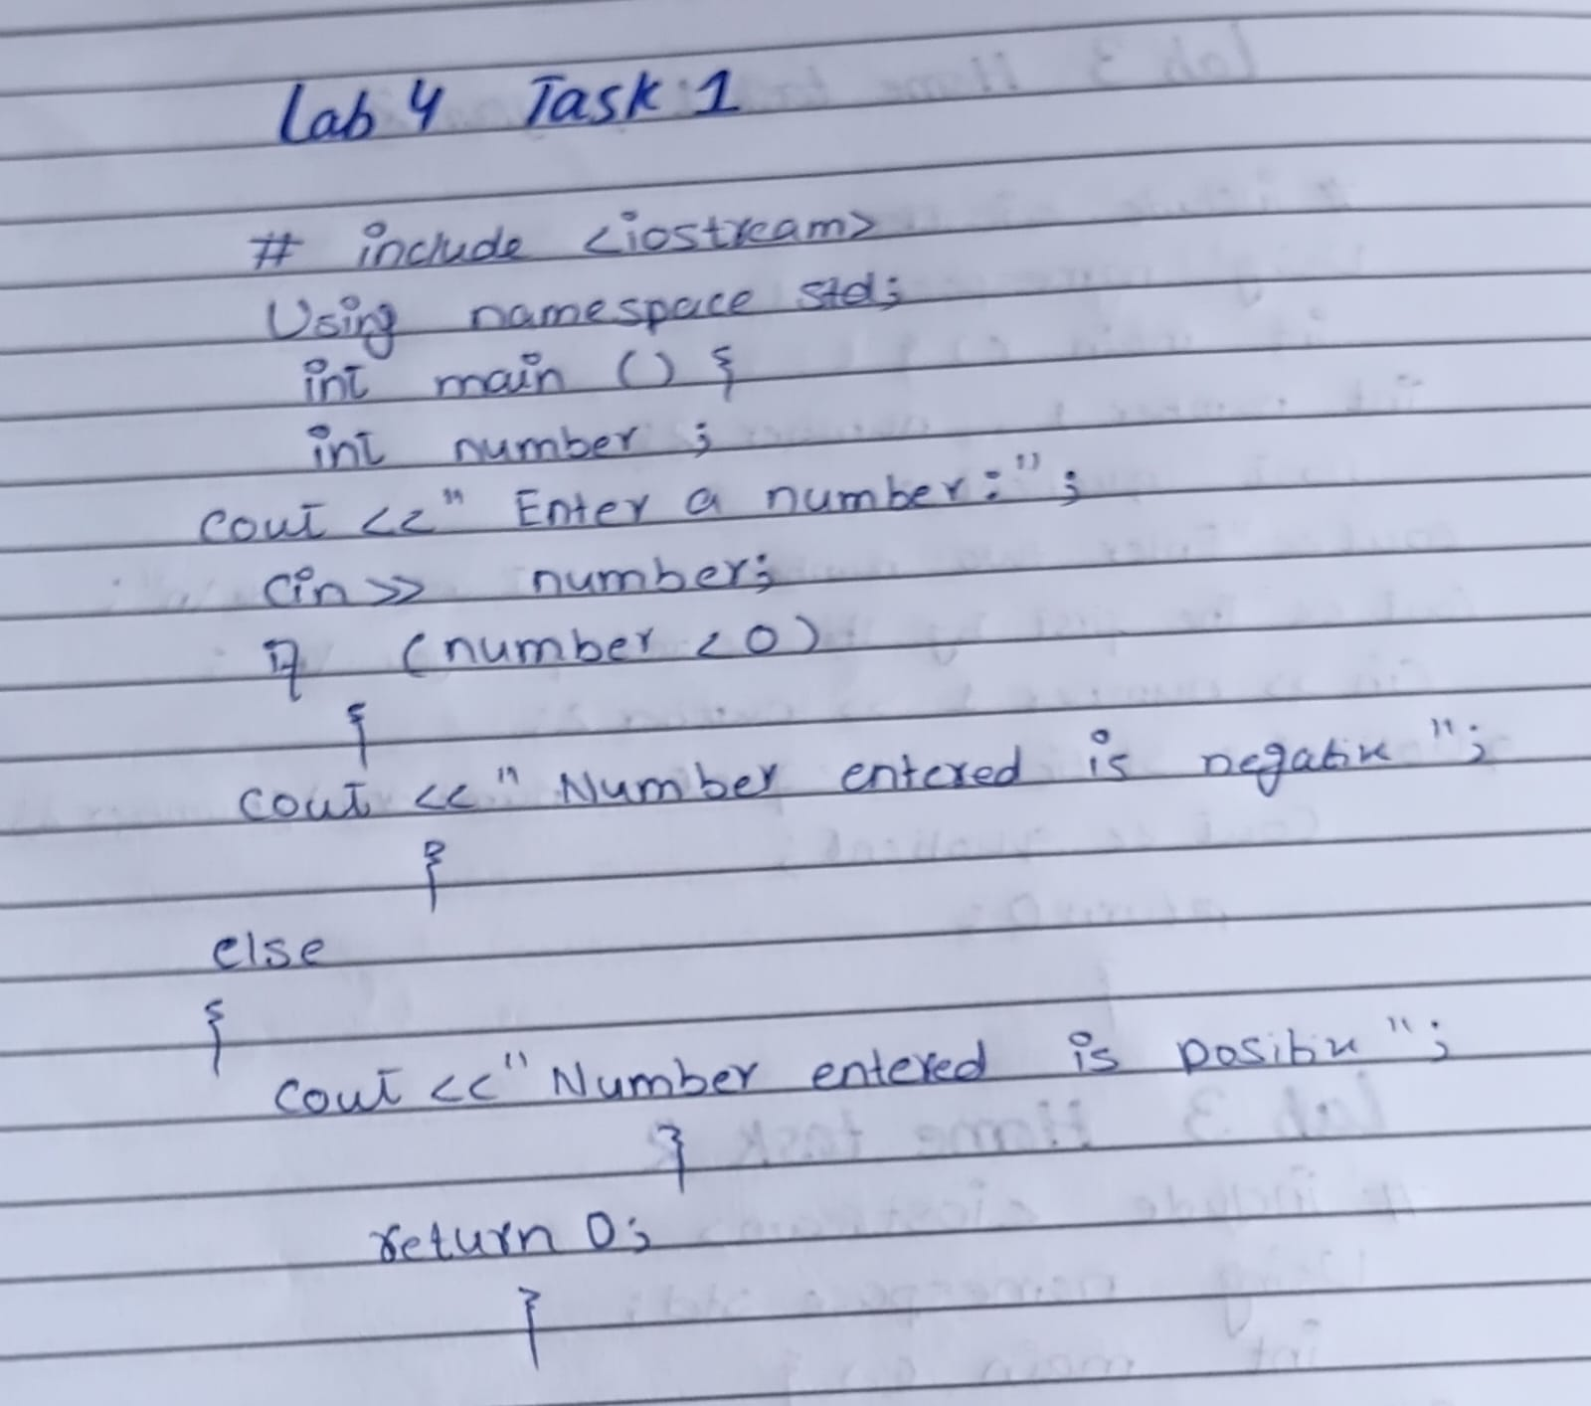
Code Written on Desktop
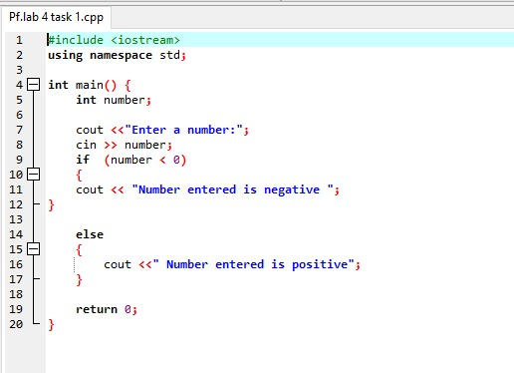

Out Put

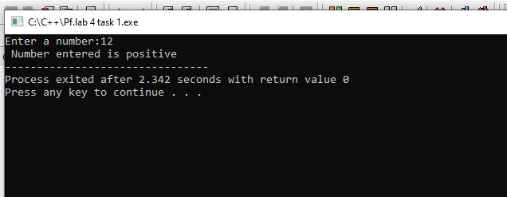

Task2:
Program to check whether an integer is positive, negative or zero.
Hand Written Code
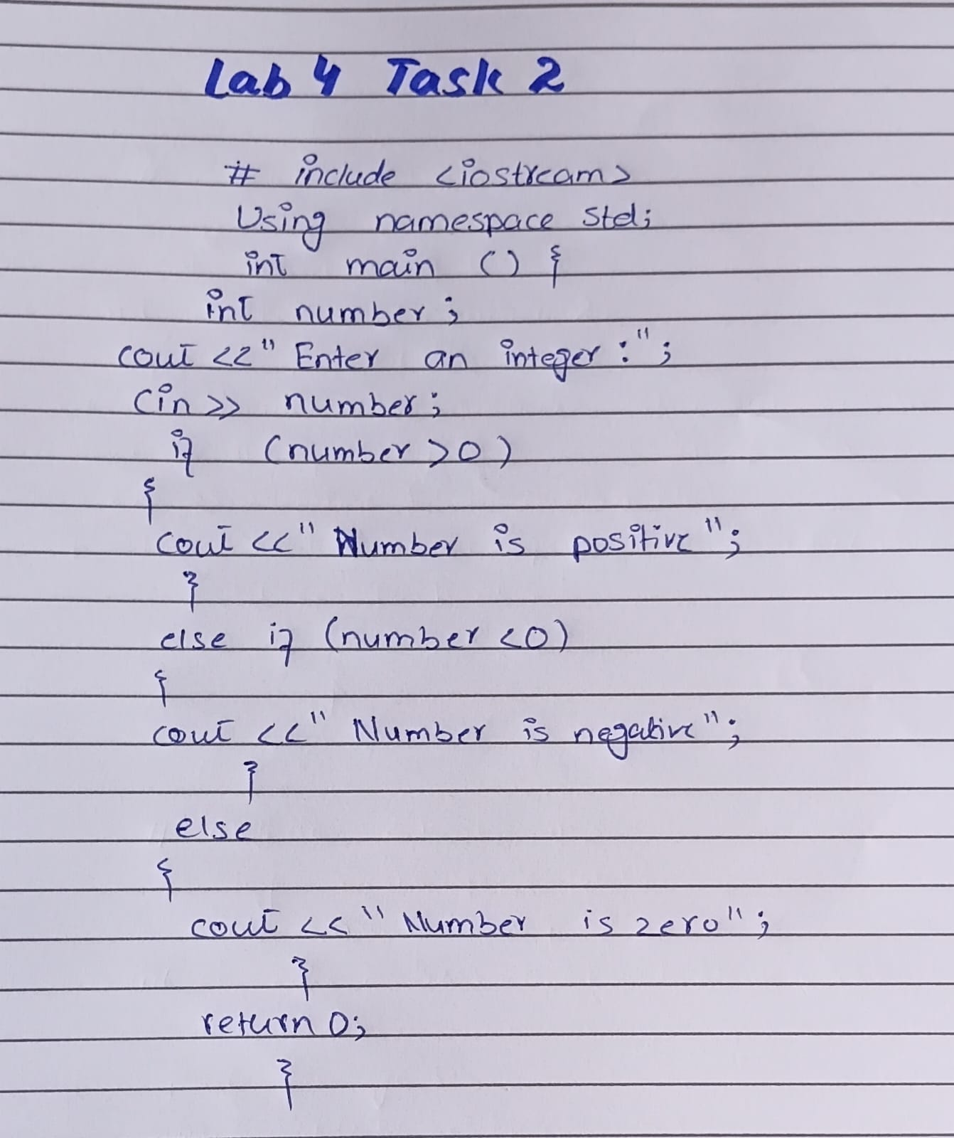

Code Written on Desktop
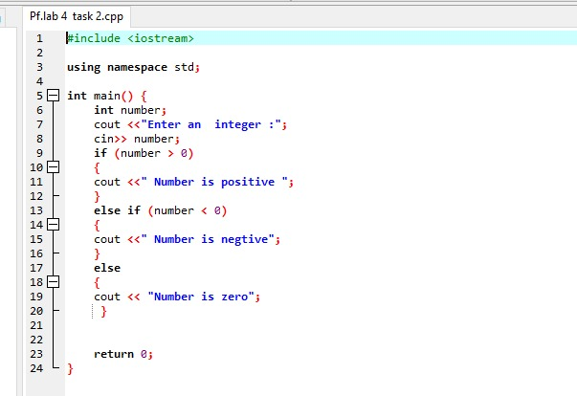
OUT Put
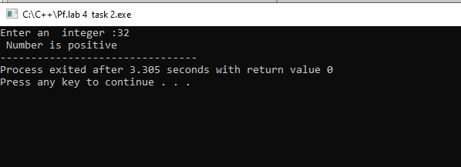

Task3:
nput : Mark
Process : If mark greater than and equal to 75, score will be A
If mark less than 75 and greater than and equal to 60, score will be B
If mark less than 60 and greater than and equal to 45, score will be C
If mark less than 30, score will be D
Output : Print the grade of your score.

Hand Written Code
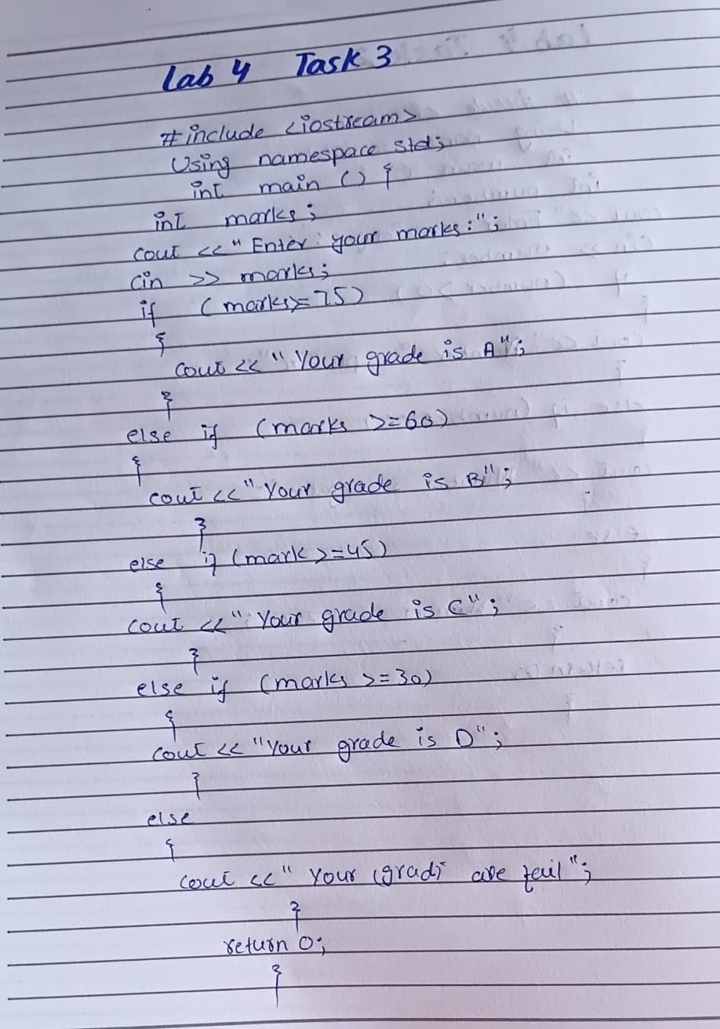
Code Written on Desktop
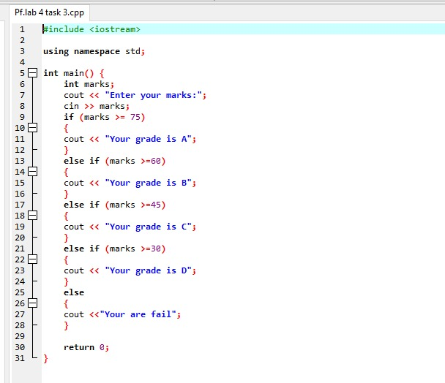
Out Put
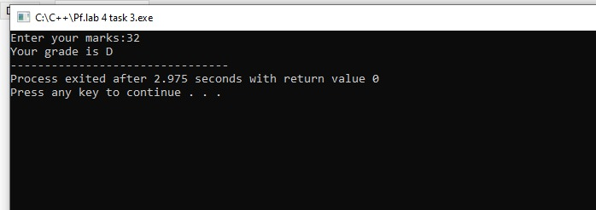

Task4:
Find Largest Number Using Nested if...else statement.
Check whether the number entered by the user is positive or not. If it is positive then calculate
how many digits the number have.
Hand Written
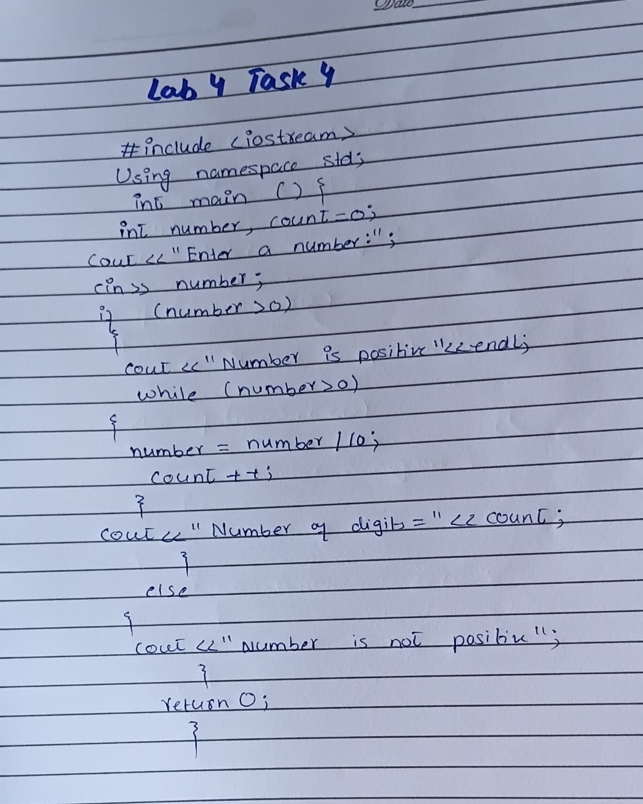
Code Written on Desktop
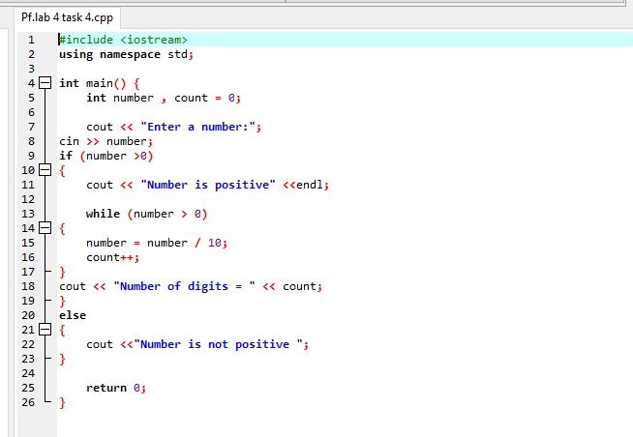
OUT Put
